JavaScript
Task(1-12)
1.Write a JavaScript program to display "Hello, JavaScript!" using console.log().
Code:
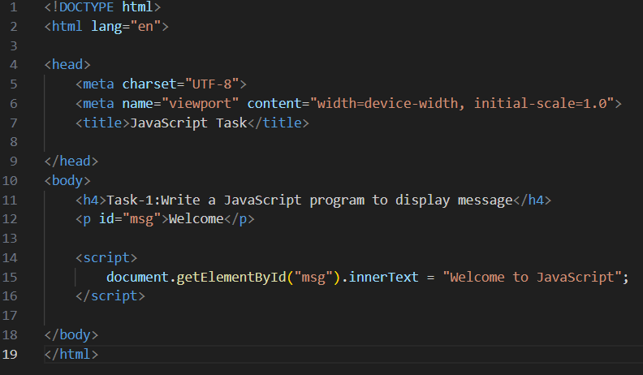
Output:
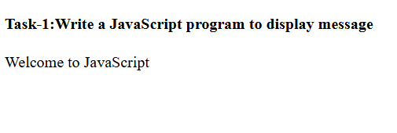
2.Create a variable using var, let, and const and print their values.
Code:
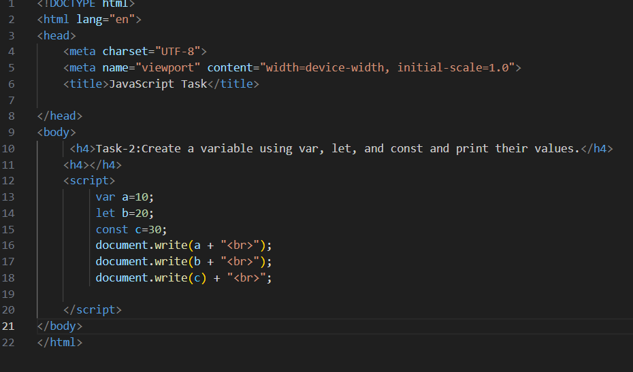
Output:
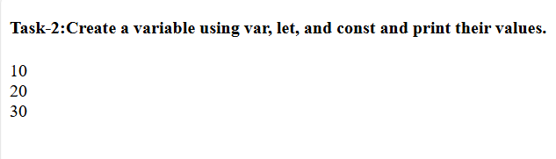
3.Demonstrate the difference between var, let, and const in terms of scope.doubt
Code:
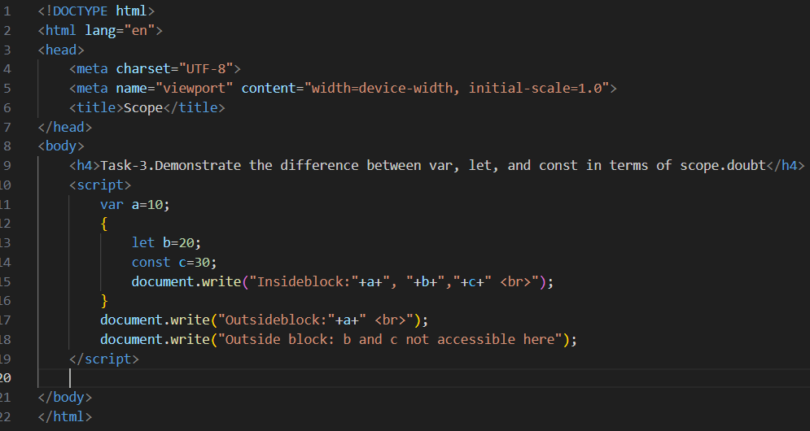
Output:
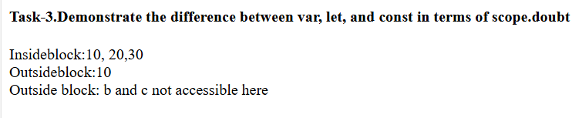
4.Check the type of a variable using typeof for different data types.
Code:
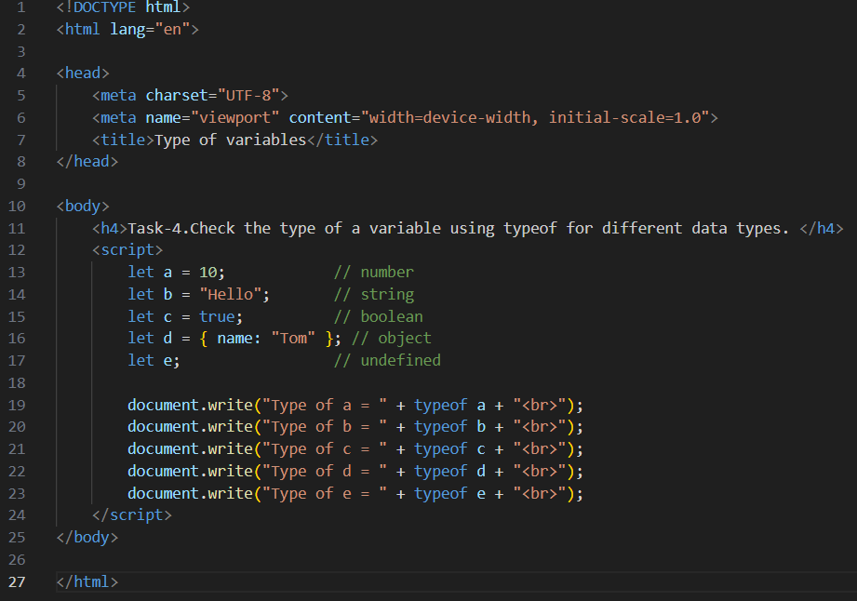
Output:
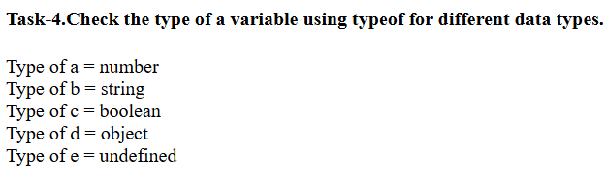
5.Create a user profile object containing name, age, and is Student properties.
Code:
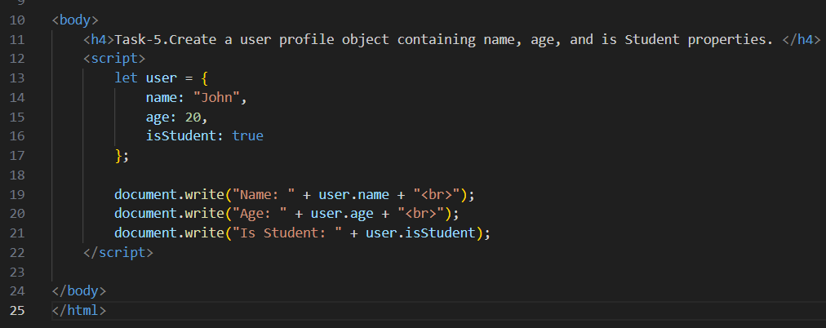
Output:
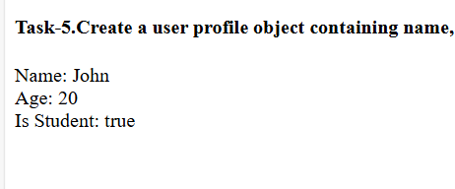
6.Store and display a list of favorite colors using an array.
Code:
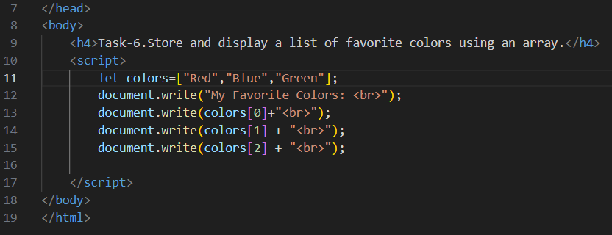
Output:
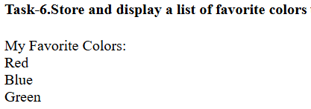
7.Perform type conversion: Convert a string "100" to a number and a number 100 to a string.
Code:
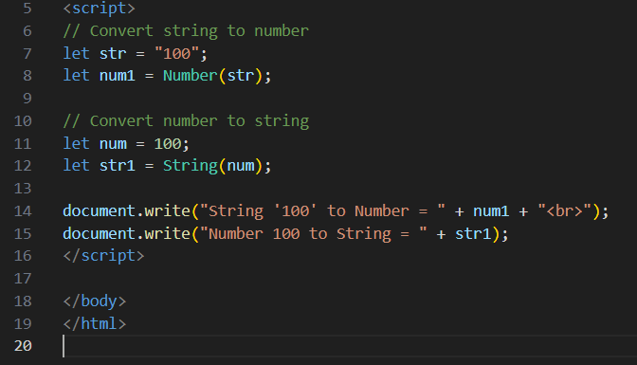
Output:
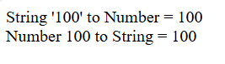
8.Write a function that returns a Boolean value based on a condition.
Code:
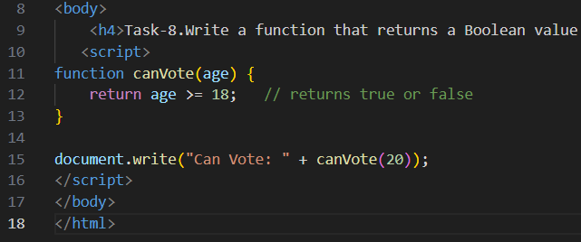
Output:
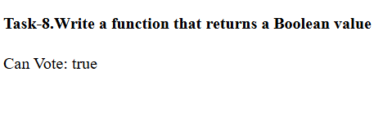
9.Demonstrate null vs undefined by creating two different variables and checking their types.
Code:
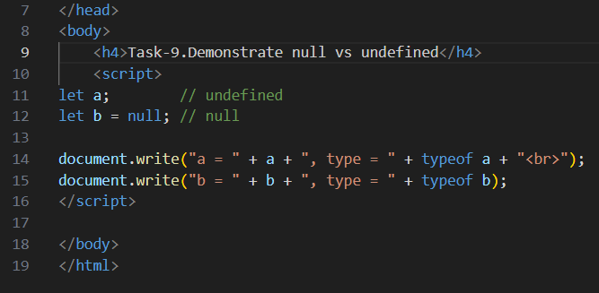
Output:
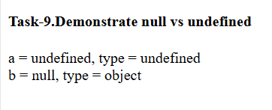
10.Use Symbol data type to create a unique ID and compare two symbols.
Code:
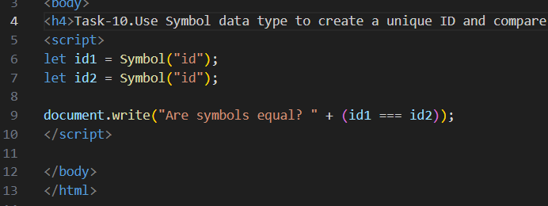
Output:
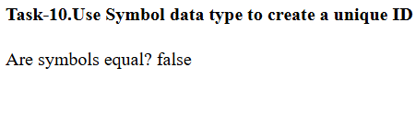
11.Use BigInt to store a large number and print its type using typeof.
Code:
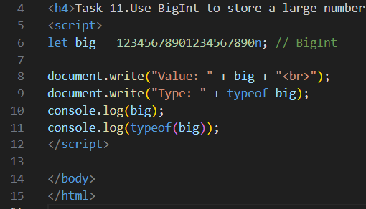
Output:
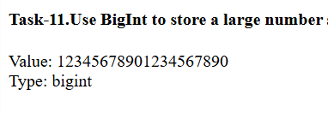

12.Write a function that accepts a number as an argument and returns "Even" or "Odd".
Code:
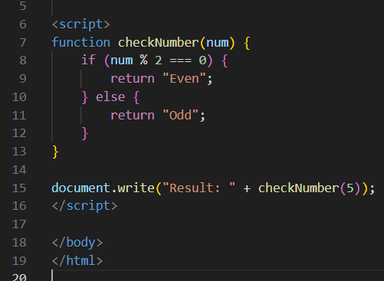
Output:
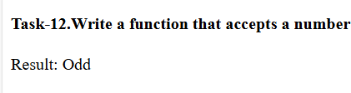
13.Create a temperature conversion program that converts Celsius to Fahrenheit using a variable.
Code:
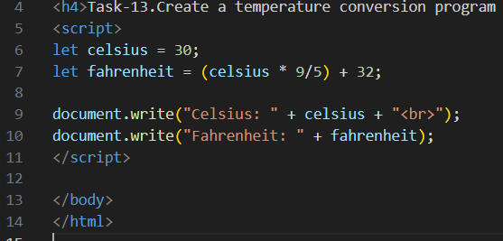
Output:
